Youden Plot – MSA Analysis

This platform allows the user to create a Youden plot along with a range chart to perform a measurement systems analysis (MSA). The plots also contain a table for various statistical metrics for interpreting the analysis.
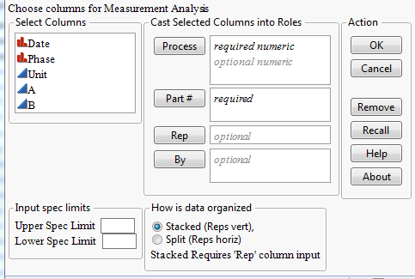
Within the dialog, the user will have several options. The columns in the table will be listed to the far left. The user will be able to move columns to three key areas:
Process, Part #, Rep, and By.

There is a section where specification limits can be applied to the Youden plot. The user manually inputs the known upper and lower specification.

In addition, the user may choose how the data is organized (Stacked or Split). Stacked data will have all measurements in one column with row information separating several measurements for a set (Part #). Stacked data will need a 'Rep' column separating one measurement from another. Split data has the measurements side by side (much like the original FIVEX excel tool).

Various actions mimic actions that are standard with JMP platforms.

Process requires at least one column, and is limited to, two numeric columns. These columns represent the measurements associated with any single part or unit. Stacked data only needs one column and split data requires two.

Part # requires, and is limited to, one column, numeric or character. This column represents the experimental unit being tested. Standard labeling simply labels the parts randomly 1-xx. Each one of these experimental units is measured twice.

Rep has one optional column. It is necessary for Stacked data and will not be used for Split data. If more than two reps are present (measurements A, B, and C) only the first two (alphanumeric order) will be used for calculations and graphing.

By is optional by the user and is unlimited in number of columns added. In addition, “Value-Ordering” preferences are not able to be maintained at this time, and will yield an incorrect table of statistics. Remove Any “Value-Ordering” column properties from your By columns before proceeding.

NOTE: Column names/headers containing commas may cause problems with the script when chosen as Part # or By variables.

Input Spec Limits allows the user to input known specification limits for the parts/units being measured.
The script will add a number of columns to the data table representing various statistical metrics for MSAs. It will then create the graphical layout pictured below.

The script will make a copy of the original data table and add a number of columns to the new data table containing the calculations for the MSA. In addition, it will create the graphical report pasted below.

In the event data points are excluded, they will be deleted from the new data table and not included in the calculations. Should the script be run on a table which already has Youden columns, they will be deleted from the copy of the table before the new columns are calculated.

Data Table Columns:
Readings (Range) – The difference in measurement for the two measurements for 1 unit
Product (Average X) – The average between the two measurements for 1 unit
MR – The mean difference for all units (average of Readings (Range))
Avg(Prod Avg X) – The grand average of the average between two measurements for all units (average of Product (Average X))
σ Unit Avg – The standard deviation of the average between two measurements (std dev of Product (Average X))
σ_{e} – Repeatability or Measurement Error = MR / 1.128
σ_{t} – The Total Variation (standard deviation) =
σ_{p} – The Product Variation (standard deviation) =
rICC – The intraclass correlation coefficient = 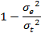
Dr – The Discrimination Ratio = 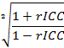

σ_{e} Pct of Total – The percent of variation from σ_{e} =

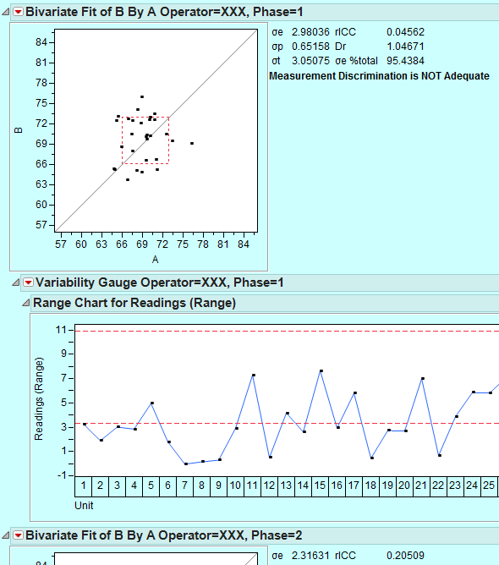
The output places the data points on the Youden plot with the specification lines in dotted red.

The range chart has reference lines at MR and UCL_{MR} = MR * 3.267. All points about UCL_{MR} are changed to an asterisk.

The inset table displays the important metrics as well as a statement if the Dr is adequate or not based on a Dr of 7⁺ being adequate.

Note: Changes to default platform settings may change appearance of graphics on a user by user basis. Script was designed to work with JMP default platform settings

